# OLTP – Load External References – Normalization of Data

## Task 01 – Install and expand load of external references T_Languages

### 

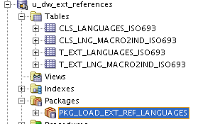

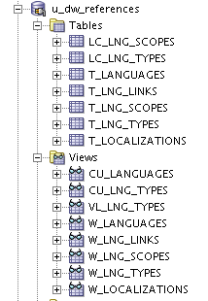

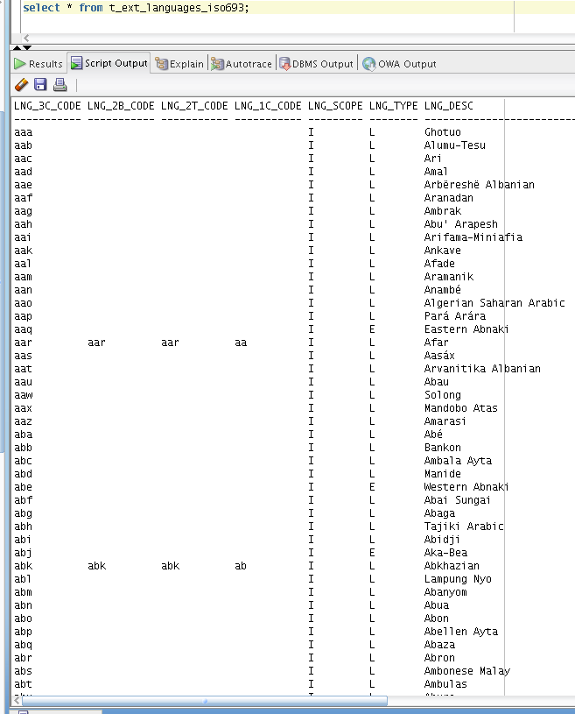

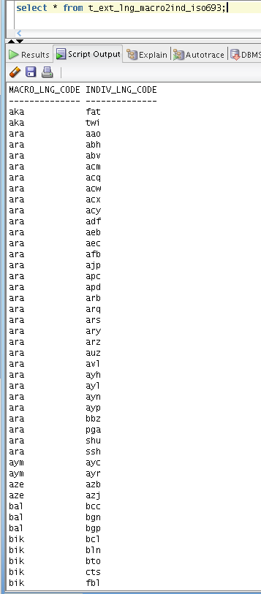

# OLAP – Business analyses task



**Solution Concept**

**1. Overview**

**1.1 Business Backgrounds**

The company sells goods and services connected with funeral in many states of USA. The main direction of providing services is organization of funeral across the country. Additionally you can buy some products for ceremony. Also company can give you a choice, how can you spent funeral, what necropolis you want to choose and do you want to have a priest or not. You can also buy some goods for funeral in the company, if you need.

**1.2 Benefits**

Using data analyze will help us to control company and improve decision making.

The main benefits are:

1. We can calculate statistics, how our offices are working. It allows us to decide in what states our business are most successful and where are not. It can help us to know where we company growth will be the most effective
2. We can analyze what goods and services are most popular with our clients, so we can choose the main direction of development.
3. We can find what necropolises are the most demand. May be it can help us to have some deals with some of them for both profit.
4. If we will have data about our work for some years, we can find in what periods we have maximum clients. So we will know how many employers and when we need for effective work.
5. When we have statistic for a long period we can plan our budget with a few mistake.

**2. Requirements**

**2.1 Business Requirements**

The main aim of building DWH system is the opportunity to perform data analyze with specializing tools. For reason main business requirements are:

1. Opportunity to calculate profit in different time periods (weeks, month, quarters, years)
2. Compare performance of different offices, groups of offices in different states, or compare work of the offices with their own work in past periods.
3. Find out what of companies services or products are most required with clients.
4. Find out clients professions or social statuses and which groups of clients are permanently.
5. Analyze what necropolises are most popular in our company.

**2.2 Technical Requirements**

1. Data Warehouse and all offices should have Internet channel enough for quick delivering of information.
2. Performance of Data Warehouse System should allow to form star scheme and to analyze data at least 1 time a week.
3. Every week auto-reports should be generated automatically. Then they should be mailed to CEO, sales managers and purchasing departments.
4. The average count of all contracts per day as will be about 500. So, we should plan about 5000 transactions per week.
5. Every week, after report creation, we should create full back up. Also we should store archive logs and incremental backups.

**3. Solution Sketch**

**3.1 Source table Structure**

Every office in company should have its own database with the same structure. Information should store in 3NF. Every day all tables copy in Flat Files and send to the DHW.

The source tables are: Contracts, Services, Funerals, Goods, Necropolis, Offices, Cities, Regions, Clients, and Professions.

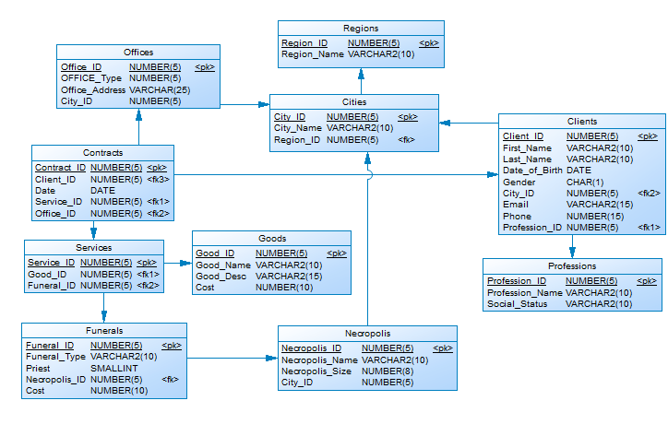

**3.2 Summarize Data plan**

The minimum time period for analyze will be a weak. Every week, after loading of data will generate reports satisfying business requirements.

This reports will show us the sum of all contracts, for all offices, analyze of all types of funeral ceremonies, sold products, most popular necropolises, clients information, cities and etc. On the base of this reports will aggregate data for month, quarters and years.